Project Development Phase
ACL Performance Test
Date | 29 September 2026
Team ID | SWTID-2026-7644
Project Name | Script-Controlled ACL – Restrict Record Access Based on Field Value
Maximum Marks | 4 Marks
ACL Performance Testing:
Project team shall fill the following information in the ACL performance testing template.
S.No. | Parameters | Values | Screenshot
1. | ACL Solution Summary | • Script-controlled ACL checks the configured record field value.  • User role / permission context is considered.  • Access is allowed only when the configured condition is satisfied. | 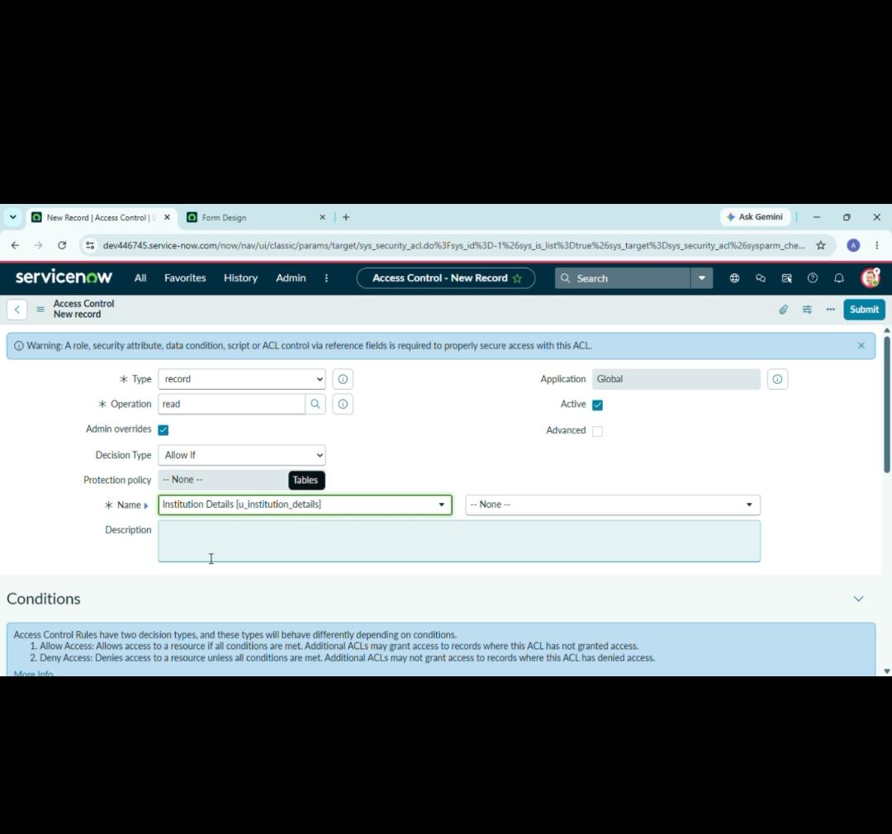
2. | Access Decision Accuracy | Authorized scenario –  Field value matches the user's permitted value: Access Allowed.  Unauthorized scenario –  Field value does not match the permitted value: Access Denied. | 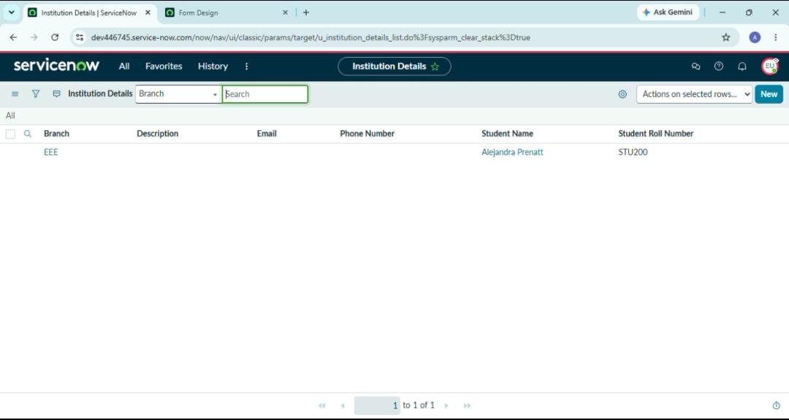
3. | Rule Tuning Result  (if Done) | Validation Result –  ACL script and field-value conditions are tested with multiple record values.  Expected Result –  Authorized users can view permitted records and unauthorized users are blocked. | 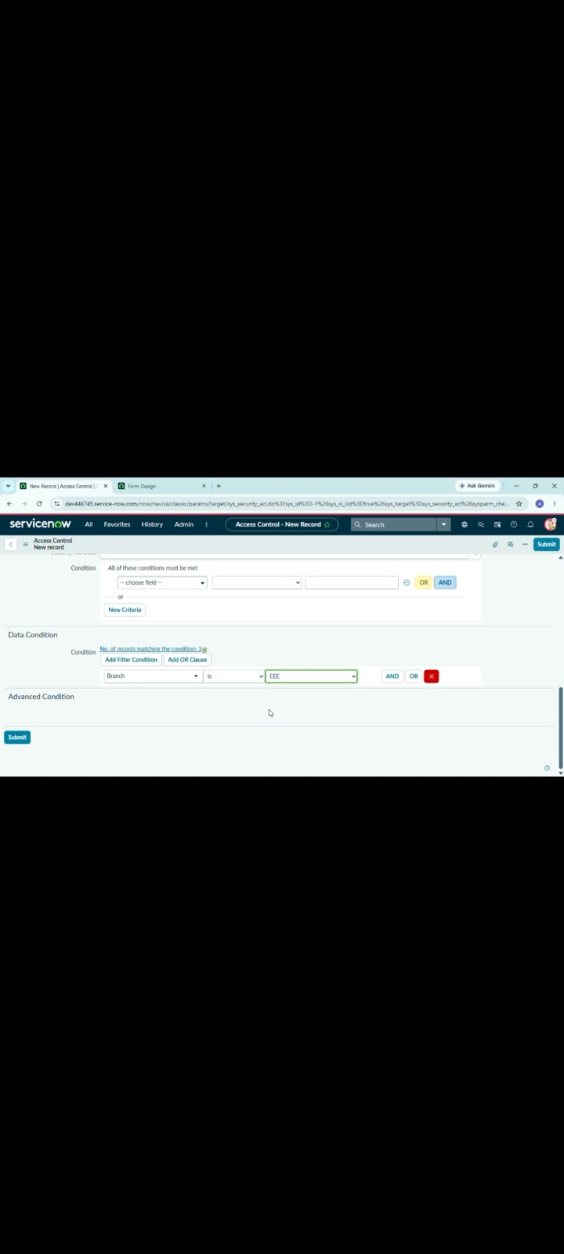  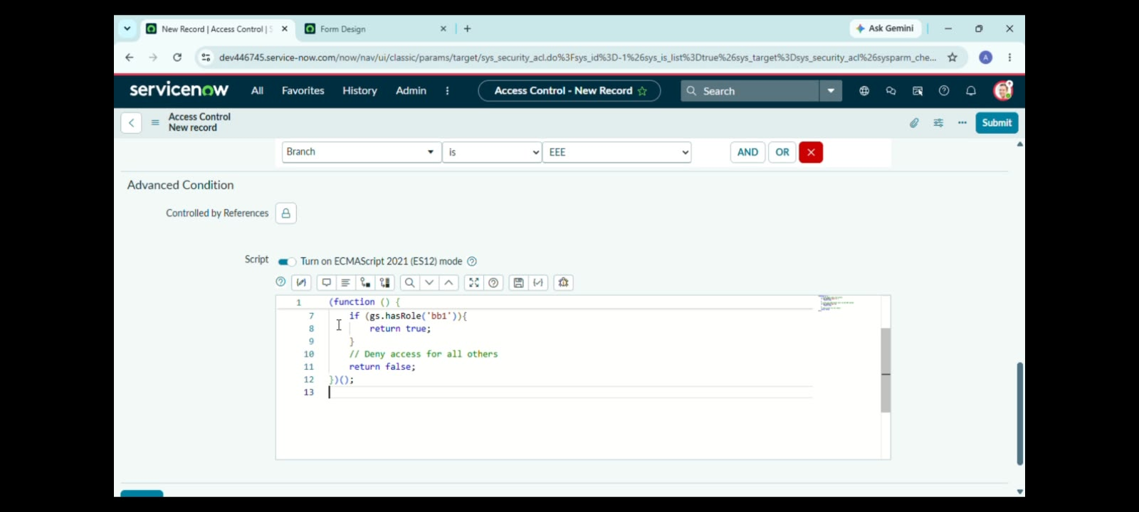
Performance / Validation Criteria:
• ACL evaluates the configured field value at the time of the access request.
• Authorized users receive the requested record when the field-value condition is satisfied.
• Unauthorized users are denied access without exposing protected record information.
• ACL scripts remain testable, maintainable and auditable.

